RY-YPZL Disc Granulation Machine
Main uses and characteristics of the equipment
The angle of pelleting disc adopts whole arc structure, the rate of pelleting can reach more than 93%, the reducer and motor adopts flexible belt transmission, the start is smooth, slow down the impact, and improve the service life of the equipment. The drive of granulating disc adopts large modulus hardened gear transmission, which improves the running quality of the equipment. The bottom of the granulating disc adopts multi-strip radial steel plate welding moulding, which is sturdy and durable and never deformed. Thickened, aggravated and solid base design, no need of ground bolt fixing, smooth running. Adjustment of the angle of the granulating disc adopts handwheel adjustment, which is simple and convenient without any tools. This machine has the advantages of even granulation, high rate of granulation, smooth operation, durable equipment, long service life, etc., and it is the ideal equipment chosen by the majority of users.

The parameter of the machine

Model | Pelletising disc diameter(mm) | Disc Rim Height(mm) | Capacity(m³) | Spin speed(r/min) | Motor power  (kw) | Productivity  (t/h) | Reducer Model
RY-YPZL25 | 2500 | 500 | 1.5 | 15.3 | 7.5 | 1-1.5 | JZQ350
RY-YPZL28 | 2800 | 500 | 2.0 | 15.3 | 11 | 1.5-2 | JZQ350
RY-YPZL30 | 3000 | 600 | 2.5 | 15.3 | 11 | 2-3 | JZQ400
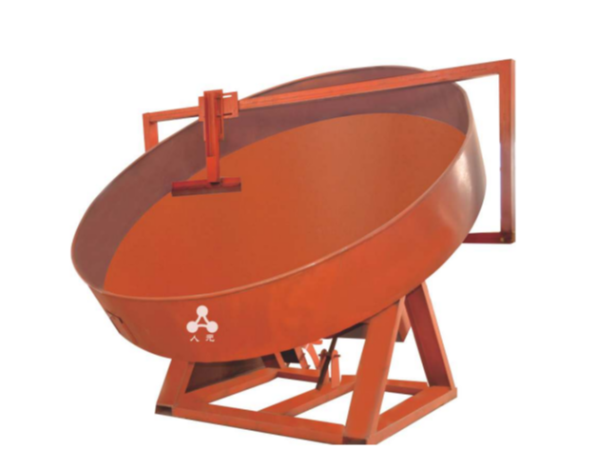  RY-YPZL32 | 3200 | 600 | 3.0 | 15.3 | 11 | 2-3.5 | JZQ400

